

**Bid number: B-GEN-2025-001**

**Bid**

**for**

**Collection, Pressure Test, Servicing & Delivery of**

**CO2 Cylinder Bottles from/to BPC**

**Note:**

**This document is confidential and for use by the invited parties only. No party may share this document with any other party, except with the prior written consent of BPC Sdn Bhd.**

#### Contents

SECTION 1 Instruction to Bidders

SECTION 2 Scope of Work

SECTION 3 Bill of Quantities

SECTION 4 Form of Bid

ATTACHMENT-A BPC Bottle Cradle

#### SECTION 1: Instruction to Bidders

1. RFQ Scope
   1. Berakas Power Company Sdn Bhd (“BPC”) invites bids from Bidders to provide “**Collection, Pressure Test, Servicing & Delivery of the CO2 Cylinder Bottles from/to BPC**”
   2. The Bidder’s Bid Submission shall be in accordance with these Bid Documents

SECTION 1 Instruction to Bidders

SECTION 2 Scope of Work

SECTION 3 Bill of Quantities

SECTION 4 Form of BID

* 1. Bidders shall examine carefully the contents of the Documents. Failure to comply with the requirements of submission will be at the Bidder’s own risk. Should the Bidder find any pages/contents missing, in duplicate, or not clear, they must inform BPC without delay in order to arrange for these to be rectified.
  2. The Documents may not contain all information which Bidders may require, save that as far as BPC is aware, the information is complete and accurate. Bidders should make their own inquiries and seek clarification as they think necessary in accordance with **Clause 3 of this Instruction to Bidder**. BPC shall not be liable to any Bidder for any information in this Request for Quote, (RFQ) being incomplete or inaccurate.
  3. Bids will be considered only if submitted according to the instructions contained herewith and in the form(s) prescribed in this Request for Quote.

1. Quote Submission Deadline
   1. The RFQ Submission Deadline is before **16.00 hours (Brunei Time) on 26 August 2025**. The Bidder is solely responsible for ensuring that the full Submissions are received by BPC prior to the RFQ Submission Deadline.
2. Amendment of RFQ Documents Prior to Submission
   1. At any time prior to the RFQ Submission Deadline, BPC may, for any reason, whether at its own initiative or in response to a clarification requested by a prospective bidder, modify the RFQ Documents by issuing an addendum to Bidders.
   2. Any addendum thus issued shall be part of the RFQ Documents pursuant to **Clause 1 of this Instruction to Bidders**, and shall be communicated in writing, by email to all bidders. Bidders shall acknowledge receipt of each addendum by email to BPC.
3. Clarification
   1. Any clarifications required by a Bidder must be requested in writing, only to the following, and no other persons.

**Name: Mark Besecker**

**E-mail:** [**quotations@bpc-brunei.com**](mailto:quotation@bpc-brunei.com)

* 1. Should the Bidder contact any other person within BPC with regards to the RFQ, BPC reserves the right in its sole discretion not to consider such Bidder’s RFQ submission.
  2. BPC shall respond to request for clarification received earlier than five (5) working days prior to the deadline for submission of RFQs. BPC will not respond to any request for clarification received less than five (5) working days before the RFQ Submission Deadline.
  3. The response to clarifications requested by any Bidder, shall be provided to all Bidders. Bidders shall acknowledge receipt of each addendum by email to BPC.

1. Deviations
   1. It shall be emphasised that the Bidders’ RFQ Submission must be in full compliance with the RFQ Documents.
   2. In case the Bidder needs to propose a deviation, the Bidder will submit this as an alternative proposal in an official letter with subject Alternative Proposal or Deviations, stating the deviations in detail with reference to RFQ Document item applicable.
2. RFQ Submission
   1. Bidders shall not make any alterations to the wording or form of the RFQ Documents issued by BPC. Any wish to alter the wording or form of the RFQ Documents should be notified to BPC by way of request for clarification.
   2. Prior to submission, should the bidder make any corrections for items filled in by hand, the bidder shall cross-out the error and write in the correction. The cross-outs and corrections must be initialled by the Bidder. No correction fluid/ tape is allowed.
   3. The RFQ Submission shall comprise of the following, which must be fully completed, signed and stamped *on every page*.
3. Section 2: Scope of Services
4. Section 3: Bills of Quantities
5. Section 4: Form of BID
6. Company profile
7. Proof of track records in undertaking similar works from 2016 to 2024 stating clients’ name, project name,
   1. **Submission by email**

Bidders must submit by email all documents listed in Clause 6.3 above to the designated email address supplied with this RFQ to be received by BPC before the RFQ Submission Deadline. Please state the RFQ number in the email subject.

Please note that the BPC email server can only receive file attachments of maximum size 4MB per email. Please send your submission in parts if required and stating the number of parts in the email subject (e.g. Part 1 of 5). Submissions as downloadable links are deemed as non-compliant and will be rejected.

An auto response message will be sent for emails that are received by the email service If you do not receive an auto response message, this could mean that your email attachment is too big or delivered to your spam folder.

1. Rejection of RFQ Submission

BPC reserves the right in its sole discretion to reject any RFQ submission which:

* + is received after the RFQ Submission Deadline
  + is incomplete in terms of its submission of **items 6.3 (all)**, or if the Sections are not being completely filled in
  + has any unauthorised alteration in the RFQ Document; or
  + has any non-compliance to any instruction in the RFQ Document.

1. RFQ Validity
   1. RFQs shall remain valid for a period of **SIX (6) months** from the RFQ Submission Deadline.
   2. BPC may request that Bidders extend the period of validity for a specified additional period.
   3. Bidders agreeing to the request will not be permitted or required to modify its RFQ.
2. Cost of Bidding

Bidders shall bear all costs associated with the preparation, submission and clarification of this RFQ (including travel expenses, etc). BPC will in no case be responsible or liable for such costs.

1. RFQ Currency
   1. The prices quoted by the Bidder shall be in the currency stated in the Section 3: **Bill of Quantities.**
   2. Bidders are advised that there is no provision in the Terms & Conditions for currency fluctuations. Bidders must allow for all risks of any costs incurred in foreign currency.
2. Language

All RFQs, supporting technical data, documentation and correspondence supplied by Bidders shall be written in the English Language.

1. Withdrawal of RFQ

No submitted RFQs may be withdrawn after the RFQ Submission Deadline. Otherwise, the Bidder shall be suspended from participating in future RFQs.

1. Acceptance or Non-Acceptance of RFQ
   1. BPC shall be under no obligation to accept the RFQ with the lowest RFQ amount, or any other RFQ, or to enter into correspondence with any Bidder regarding the reasons for non-acceptance of a RFQ.
   2. BPC reserves the right to accept portions of a RFQ as BPC may in its sole discretion decide and the RFQ Amount shall be based on the accepted portions.
   3. The issue by BPC a Purchase Order accepting a RFQ or part of a RFQ shall create a binding agreement between BPC and the relevant Bidder, thereby obliging such Bidder to provide to BPC the scope as specified in the RFQ (or such part of the RFQ as may be accepted by BPC). It should be noted that the Scope of Supply/Bill of Quantities and the completed specification (if relevant) are also part of the RFQ acceptance Terms & Conditions.
   4. The offer of a bribe or other inducements to any person, with a view to influence the award of the RFQ will result in the instant rejection of the Bidder.
2. Confidentiality
   1. Bidders shall not disclose any part of this RFQ Document (any information, data, specifications, plans, drawings, instructions or other material or document, etc) to any other party (e.g. agent, sub-contractor, etc) except with the prior written consent of BPC. All information shall be treated by the Bidder on a strictly confidential basis. The Bidder may make such disclosure directly to relevant persons solely for the purpose of preparing its RFQ, provided that the Bidder shall prior to making such disclosure:
      1. promptly notify BPC of the identity of such relevant persons;
      2. procure and ensure that such persons shall observe the provisions of this **Clause 14**; and
      3. if deemed necessary by BPC (in its sole discretion) procure and ensure the persons shall provide to the Client an undertaking in similar terms of this **Clause 14** in respect of such information.
   2. BPC reserves the right to require an unsuccessful Bidder to return or destroy any specifications, plans, drawings, instructions or such other material or document as may be issued by BPC, and such unsuccessful Bidder should do so immediately.
   3. Should any Bidder be found to have released any information on the RFQ Document or on this RFQ in any form, to any other third party without prior written consent from BPC, the RFQ Submission from such Bidder shall be rejected, and the Bidder shall be suspended from participating in future RFQs.
3. Subcontracting

Any Subcontracting of the RFQ scope the bidder to identify the portion of the subcontracting works.

1. Conflict of Interest
   1. All bidders are required to identify any conflicts or potential conflicts of interest.
   2. If the Bidder has a personal or professional connection with BPC or has undertaken work for companies or any organization which may present a conflict of interest, non-disclosure of such association may result in the disqualification of the Bidder. An example is past or current working relationship, affiliation or association with any other bidders or potential bidders.
   3. In the event of any such conflict or potential conflict BPC shall, at its absolute discretion, decide on the appropriate course of action and the decision of BPC will be final and binding in this regard.
   4. To this end all Bidders must complete and sign the Conflict-of-Interest Declaration included in Section 4: Form of Bid.
2. **Disclaimer**

BPC shall not be held responsible for any loss, injury or damages suffered by the Bidder or their employees or agents in preparing the RFQ or for any action whatsoever taken by a third party for any costs, loss, injury or damages suffered as a direct result of, or consequential to, the preparation of the RFQ.

**SECTION 2:** **SCOPE OF SERVICES**

**Introduction**

BPC intends to engage a company ("Contractor") who is competent and has good safety record, expertise and experience for conducting pressure test and servicing of BPC’s existing CO2 Cylinder Bottles

The Contractor shall provide the Services as per below:

Collection of CO2 Cylinder Bottles with Co2 and attached valve heads from BPC Warehouse which will be in sets of 10 ea. or 12ea. one set at a time. In addition, the required number of 5/8 inch Check Valve Type “I” will be free issued by BPC from BPC’s Warehouse.

Conduct inspection and pressure testing of the Co2 cylinders according to **ISO-6406:2005** standard:

* Remove and recover the CO2 from the Cylinder Bottles
* Conduct the Gas Cylinder Pressure Test.
* Replace all the 5/8 inches Check Valve Type “I”.

P.N. WK-800760-000.

* Recharge the serviced CO2 Cylinder Bottles.

Charge Capacity: 100 lbs (pound mass) of CO2.

* Stamp the Empty and Full Weight of Cylinder in lbs (pound mass)
* Clean and Repaint (Epoxy Paint – Red RAL-3000) each CO2 Cylinder Bottle

Delivery of the CO2 Cylinder Bottles back to the BPC Warehouse with certification.

**Contractor’s Responsibilities**

**Collection and Delivery of Co2 Bottles:**

The Contractor shall:

* Ensure that the lifting equipment is of satisfactory quality, is fit for its intended purpose and has valid certification.
* Be responsible for the entire lifting operation, including providing the most appropriate equipment and accessories, and where relevant, supervise the lift.
* Carry out its obligations so as not to interfere unnecessarily or improperly with the convenience of the public or with any activities at the BPC Warehouse.

**Personnel:**

The Contractor personnel shall:

* Submit proof that his manpower undertaking the Services are in receipt of valid IC documentation, valid work permits, proof of training.
* Uphold high standards of health and safety at all times ensuring that employees engaged in work are equipped with all the appropriate personal protective equipment / clothing.
* The Contractor shall provide documented evidence that their relevant personnel providing the Services are suitably qualified and have the valid certification to carry out the lifting for collection and delivery of CO2 Cylinder Bottles.
* Failure to comply with BPC’s safety requirements will preclude the Contractor from access to BPC facilities and shall be regarded as a material breach of the conditions of the contract.

All documented evidence must be submitted for review prior to delivery/collection commencement

**Equipment:**

The Contractor shall provide documented evidence of testing and certification for all equipment which are to be

used for the pressure testing.

The Contractor shall provide the required equipment for the transportation, loading and unloading of all cradles containing the CO2 bottles at BPC’s warehouse.

The Contractor shall be liable for all insurances that may be required for the testing and delivery of the Co2 bottles.

**Confirmation of Services**

BPC shall contact the Contractor’s Liaison by phone or email to inform of the awarding the contract for services.

BPC shall contact the Contractor’s Liaison by phone or email to schedule the date(s) when Services are required, and

the Parties shall agree on the dates for collection and delivery.

**Payment for Services**

The Contractor may invoice BPC based on the delivery of each set to BPC’s warehouse and the final verification of the

certification.

**Non-Performance by the Contractor**

BPC reserves the right to terminate this agreement, should the Contractor in the opinion of BPC fail to perform to the

reasonable satisfaction required, which includes the following:

* Failure to comply with BPC’s HSE procedures;
* Insufficient resources (equipment or manpower) required to undertake the Service;
* Failure to provide the Service as per the required specifications;
* Any incidences of injuries, accidents or failures;

**Contractor Profile**

The Contractor shall submit his profile containing at the minimum the following information: -

* Business registration and any amendments thereafter;
* List of Equipment and valid certification and expiration date;
* List of relevant personnel and their valid certifications and expiration date;
* The Contractor’s supervisor and his valid certifications and expiration date.

**SECTION 3: Bill of Quantities**

1. This Bill of Quantities must be read in conjunction with the attached Section 2 Scope of Services.
2. The bid price for the Works shall be fixed price lump sum and represents the full cost to the Client for the performance and delivery of the Works by the Contractor.
3. The rates in these bills shall include labour, equipment and tools, consumables, transportation, materials, etc, deemed necessary to complete the works required in all aspects. The Contractor shall undertake to do or cause to be done all things necessary for satisfactory completion of the scope of supply, work and services.
4. The bid shall be firmed in BND currency as stated in the Form of Bid and the Bill of Quantities.

**Schedule of Pricing for Collection, Servicing and Delivery of existing CO2 from/to BPC’s warehouse.**

|  |  |  |  |  |
| --- | --- | --- | --- | --- |
| **Item** | **Description** | **Qty.** | **Unit Price (BND)** | **Amount (BND)** |
| **1** | **Collection, Servicing & Delivery of the CO2 Cylinder Bottles from/to BPC Warehouse** | | | |
|  | * **12 Cylinder Bottles** in **1 Set**   (2 racks of 5 CO2 Cylinder Bottles and 1 rack of 2 CO2 Cylinder Bottles)   * **10 Cylinder Bottles** in **1 Set**   (2 racks of 5 CO2 Cylinder Bottles)  **\*1 Set** includes both trips for **Collection, Servicing** and **Delivery** of the CO2 Cylinder Bottles from BPC Warehouse and return to BPC Warehouse.  **\*\***Weight of **EACH** Cylinder Bottle:  Empty Weight = **200 lbs** & Full Weight = **300 lbs**. | 3 Sets  3 Sets | ________  ________ | ____________  ____________ |
| **Total Amount (BND)** | | | |  |

**Grand Total Amount in Words (BND):**

__________________________________________________________________________________­­­______

________________________________________________________________________________________

**Completion Time:**

* Delivery Time: ………… weeks from collection at BPC’s warehouse to return to BPC’s warehouse for **each** Set.
* Note: BPC only has one set of spare Co2 bottles. The selected contractor will complete one set, deliver to the BPC warehouse, then arrange the next date for collection of the next set.

__________________________ __________________________

Signature and Company Stamp Date

**SECTION 4: Form of Bid**

To:

The RFQ Committee,

Berakas Power Company Sdn Bhd (BPC),

Berakas Power Station,

Lebuhraya Rimba / Jalan Utama Terunjing,

Kg. Terunjing Baru, Berakas BB1514

Brunei Darussalam

**Bid for the Collection, Servicing & Delivery of the CO2 Cylinder Bottles from/to BPC Warehouse**

1. Being duly authorised to represent and act on behalf of …….…………………………………………….………….… (“Bidder”), and having carefully examined, fully understood and agree to comply with the requirements of all the Bid Documents provided (*Section 1: Instruction to Bidders, Section 2: Scope of Services, Section 3: Bill of Quantities, Section 4: Form of Bid,* the undersigned, hereby offer to execute and complete the works specified in the Bid Submissions attached to this Form of Bid for the Bid Amount of:

(Amount in numbers) **BND** .........................................................................

(Amount in words): **Brunei Dollars**................................................................…………………...……...……...……...…...…

................................................................…………………..……...……...……...….....…

Guaranteed Completion Time for:

* Delivery Time per set: ………… weeks from Co2 bottle collection to delivery to BPC for **each** Set.

1. Bidder confirms that the Bid Amount has been calculated on a firm price basis, and if accepted, shall become the Contract Price and shall remain valid for the duration of the contract period.
2. This Bid shall remain valid for a period of **six (6) months** from the date of this Form of Bid.
3. This Bid is made in the full understanding that:
   1. BPC reserves the right to reject or accept any Bid;
   2. BPC is not bound to accept the lowest or any Bid received;
   3. BPC will not be under any obligation to inform the bidders of reasons for such actions.
   4. BPC reserves the right to accept portions of a bid as BPC may in its sole discretion decide and the Bid Amount shall be based on the accepted portions
4. Bidder confirms in signing this Form of Bid, that the Bidder accepts all the terms of the Bid Documents, and that all costs incurred by the Bidder in preparing and submitting this Bid will be borne by the Bidder.
5. Bidder confirms that the Bidder and all his personnel understands and shall fully comply with all BPC HSE Procedures and BPC Contractor Handbook (including all subsequent revisions) and all relevant safety rules and regulations implemented by the relevant Government Authorities (i.e., Ministry of Development Health Safety & Environment Manual, Workplace Safety and Health Order 2009, and all its subsequent regulations and orders, etc).
6. Bidder confirms that:

Bidder understands that the servicing of ‘sets’ of bottles will be conducted one set at a time over several months.

Bidder has read and understood all the BPC HSE Procedures and BPC Contractor Handbook which are available online at [Contractors – Berakas Power Company Sdn. Bhd (bpc-brunei.com)](https://www.bpc-brunei.com/contractors/#reference-documents) .

If awarded this bid, Bidder agrees to abide by all BPC HSE Procedures and guidelines set in the BPC Contractor Handbook (and all subsequent revisions) and agrees to disseminate it to all Bidder’s employees and personnel concerned with the project. Bidder agrees to keep abreast of any revisions to the BPC Contractor Handbook by visiting the BPC website as stated in the handbook on a regular basis.

1. Declaration of Scope to be Subcontracted:

Bidder declares he confirms the Bid scope will be wholly undertaken by the Bidder

Bidder declares he will undertake the main scope and will only subcontract part of the scope that is considered as minor works and has attached details required together with this Bid Submission

Bidder declares the main scope of this works will be subcontracted to the following subcontractor:

1. Bidder confirms the following:
   1. Risk Assessment & Method Statement (RAMS) and Safety Induction Course: Bidder shall provide the Risk Assessment & Method Statement (RAMS) to BPC for review and approval and ensure all contractor personnel working on site shall attend the Safety Induction Course prior to commencement of site work.
   2. Failure to Perform: For defaults on Performance, Bidder shall make payment for the default in accordance with the Contract.
2. Bidder confirms that if awarded this bid, payments to the Bidder shall be made into the following account:

Account Name: ………………………………………………………………………………….

Account Number:………………………………………….. Bank Name: ………………………………………………………

1. Bidder confirms that he has not granted, sought, attempted to obtain or accepted and will not grant, seek, attempt to obtain, or accept any advantage, financial or in kind, to or from any party whatsoever, constituting an illegal or corrupt practice, either directly or indirectly, as an incentive or reward relating to the award of the bid/contract.
2. Declaration of Conflict of Interest(refer Section 1: Clause 16 Instruction to Bidders: Conflict of Interest)**:** Bidder hereby declares and fully discloses any conflict of interest or potential conflict of interest pertaining to this bid. Bidder undertakes to inform BPC of any changes to this Declaration of Conflict of Interest or any other conflicts of interest which may arise or become apparent during the course of this bid process.

Bidder accepts that BPC may take appropriate action in relation to conflicts of interest, and that Bidder may be excluded from bidding for a specific contract where the effect of the conflict of interest has not been dealt with to the satisfaction of BPC.

Bidder declares there is potential conflict of interest which might have an impact on his ability to offer/deliver the services in question to BPC

No Yes If Yes, please provide details: ……………………………….……………………………………..….

|  |  |  |  |  |  |
| --- | --- | --- | --- | --- | --- |
| Name : |  | | | Designation: |  |
| Authorised Signature & Seal: | | |  | | |  |
| Address: | |  | | | |  |
| E-mail address: | |  | |  | | |
| Mobile No: | |  | | Office Tel. No: |  |  |
| Date: | |  | |  | | |

**Attachment-A**

Photos of rack containing Co2 Bottles:

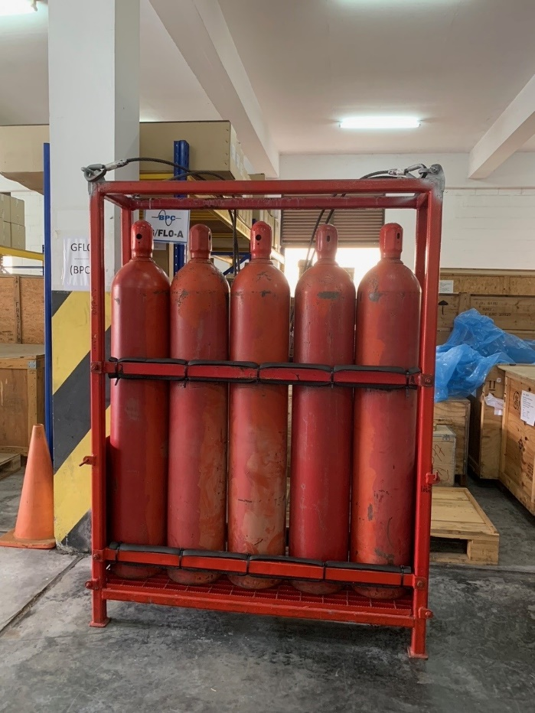

5 Bottle Rack

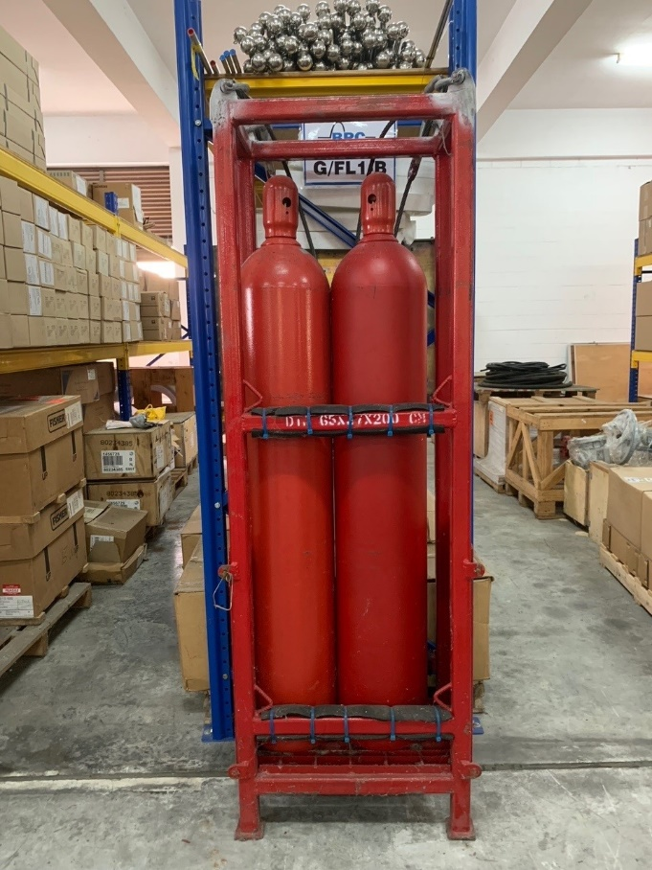

2 Bottle Rack